**Leader Overview**

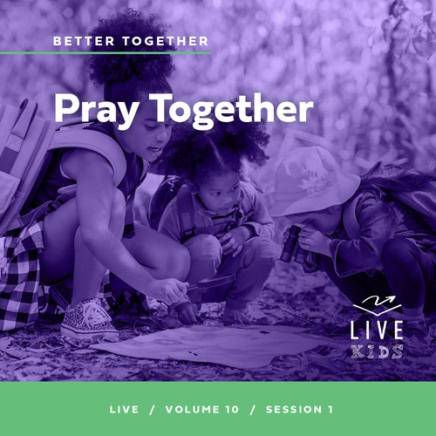

**Volume Overview**

**Better Together**

*The Christian life is never lived alone. When we become a Christian, we’re adopted into God’s family. We’re welcomed into a community. We’re meant to live and grow in faith together. But that takes humility and intentionality. We grow together as we pray and study Scripture together. We bear responsibility for one another by our encouragement and our honoring of those in authority. God is growing us together as one body, one family.*

**Session Overview**

**Pray Together**

*In this* **Live** *session, kids will discover the importance of praying with others. As we pray together for each other’s needs, God will listen and respond to our prayers. Our prayers are powerful and effective when we pray with faith and believe that God hears and answers us.*

**Bible Lesson**

The Church Prays and Peter Is Set Free

[Acts 12:1–16](https://ref.ly/logosref/Bible.Ac12.1-16)

**Faith Fact**

Our prayers are powerful.

**Faith Verse**

[Ephesians 4:3](https://ref.ly/logosref/Bible.Eph4.3) (NLT)

Make every effort to keep yourselves united in the Spirit, binding yourselves together with peace.

**Preparing for the Session**

**Leader Preparation Time: 20–25 Minutes**

|  |
| --- |
| ***You Will Need***  ***Large Group***   * *Bible* * *Worship songs (Song suggestions: “Good Grace” by Hillsong United; “Speak Life” Lyric Video by TobyMac; “Tremble” by Bethel Music)* * *For groups not using a phone or tablet only, add:*   *• Projector or TV*  *• Laptop*  *•* ***Faith Fact Slide***  *•* ***Faith******Verse Video or Slide***  *•* ***Bible Lesson Video***  *•* ***Teaching Point Slides 1–3***   * *Toy handcuffs* * *Flashlight* * *Pillow*   ***Small Group***   * *Yarn, long enough to wrap around each kid in the group with space in between.* * *Bibles for kids in the group to share* * *Balloons, two or three per group* * ***Small Group Activity Page****, one per kid* * *Pencils or pens, one per kid*   *To access session content and videos from a computer, visit:* [BibleEngagementProject.com/downloads](https://bibleengagementproject.com/downloads) |
| ***Getting Ready***  ***Large Group***   * *Download videos and slides if needed.* * *Select worship song(s) and have them ready to play.* * *Read the Bible Lesson Scripture to prepare for Teaching Time.*   ***Small Group***   * *Print copies of the* ***Small Group Activity Page****, one per kid.*   *First time leading* Live *for Kids? Check out the* [Facilitator Guide](https://0b769b0ed3569ef9d18b-f88d8272f61086866d50d048b43ef630.ssl.cf2.rackcdn.com/sites/biblengagementproject/Listen_Facilitator_Guide.pdf)*.* |

**Large Group**

**30 Minutes**

*See what’s needed at the beginning of the session.*

**Introduction**

I’m so excited to see all of you today. Why? Because we’re better when we are together. I want us all to stand up, link arms with each other, and say, “Better together.” *(Group response)*

That’s one of the incredible things about being a follower of Jesus. We’re a part of God’s family, which is made up other believers who can support and help each other. We are never alone because we are a part of His Church. Let’s find out how we are better together.

We are better together because we can pray for each other’s needs. The Bible helps us know that our prayers can make a difference in the world. God hears our prayers, and He responds to our faith in Him. It can help us have more faith when we’re praying with other people.

• *Optional: Insert a personal story about a time when you prayed with a group of people for a need or people prayed for you, and God answered in a memorable way.*

• *If you can’t think of a personal story immediately, tell a story about God responding to a group of people praying in the Bible or in the past.*

**Faith Fact**

Prayer is so much more than just speaking words. Our prayers are powerful because the One we’re talking to is God. Our Faith Fact today is **Our prayers are powerful.**

• *Show the* ***Faith Fact Slide.***

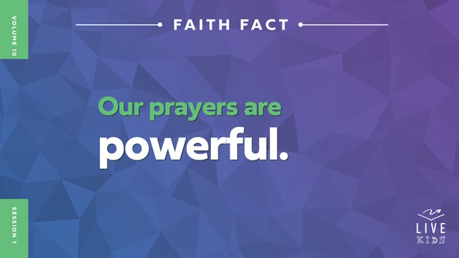

Let’s say the Faith Fact again while we flex our muscles *(demonstrate)* to show that there is power behind our prayers. **Our prayers are powerful**. Let’s say that one more time. **Our prayers are powerful.**

**Game**

**Share a Prayer**

We can talk to God alone or together with others. Praying alone is a great way to get to know God better. He wants to talk with us. Praying together allows others to join with us as we ask for God’s help.

Let’s play a game together called Share a Prayer. I’ll start by whispering a short prayer to one of you, and that person will keep passing it along to the next person. We’ll see if we can share the same prayer all the way down the line.

• *If your group is large, break into two or more teams.*

• *Choose one or more of these prayers:*

• God is great. God is good. Let us thank Him for this food. Amen.

• Come, Lord Jesus, be our guest. Let this food to us be blessed. Amen.

• *Now I lay me down to sleep*, I pray the Lord my soul to keep. Amen.

Did anyone recognize any of these prayers? *(Group response)* These prayers are ones that young kids might pray together with adults before meals or at bedtime. I’m glad our prayers don’t have to be something we memorize. Thankfully, we don’t have to whisper them to pass them along. We don’t have to keep them a secret. We can share our needs with each other and pray aloud. **Our prayers are powerful.**

**Worship**

Praying together is powerful! We can even pray to God through our worship. When we combine prayer and worshipping God, imagine how powerful that could be! God hears our prayers and our worship, and He will respond to us.

• *Lead the kids in singing one or two praise songs. See suggestions at the beginning of the session.*

**Bible Lesson**

I love it when we worship together, and I know God loves it even more. Let’s pray and ask God to show us how powerful our prayers are when we pray together.

**Prayer**

|  |
| --- |
| *Dear God, thank You for the time to come together with others who love You. Help us to understand the importance of praying together as we look at what Your Word teaches us. Amen.* |

**Video Intro**

Before we look at the Bible story, let’s watch this video.

• *Play* ***Bible Lesson Video****.*

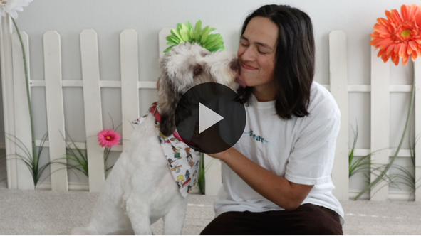

**Bible Story**

**The Church Prays and Peter Is Set Free**

That video was a great lead-in to our Bible story today. Raise your hand if you would have loved to have been one of Jesus’ followers when He was here on earth. *(Group response)* It sounds like an incredible opportunity, but being a part of the Early Church was far from easy.

After Jesus went back to heaven, His disciples and other followers continued to work together to spread the good news about Jesus. They did an amazing job of helping more people come to know Jesus. Others didn’t like the work that Jesus’ followers were doing, so they tried to stop them. Some of the believers were beaten, put in prison, and even killed for following Jesus and telling others about Him.

**Teaching Time**

|  |
| --- |
| ***You Will Need***   * *Toy handcuffs* * *Flashlight* * *Pillow*   *No prep needed for this activity.* |

It was a risky time to be a follower of Jesus, so these followers knew they needed each other. When one of them was in trouble, the rest of the Church prayed for them. God heard their prayers and saw their faith in Him. Sometimes He responded to their prayers in incredible and miraculous ways. Let’s read about how God responded when Peter was in trouble. Grab your Bible or pull up a Bible app on your device. Turn to [Acts 12:1–16](https://ref.ly/logosref/Bible.Ac12.1-16).

• *In order to keep Large Group time moving along, we recommend that the leader reads the Scripture portions aloud.*

• *Optional: Remind the kids to mark this place with their Bible bookmark so they can read it on their own at home.*

**1. Peter was taken to prison and the Church prayed.**

• *Show the* ***Teaching Point 1 Slide.***

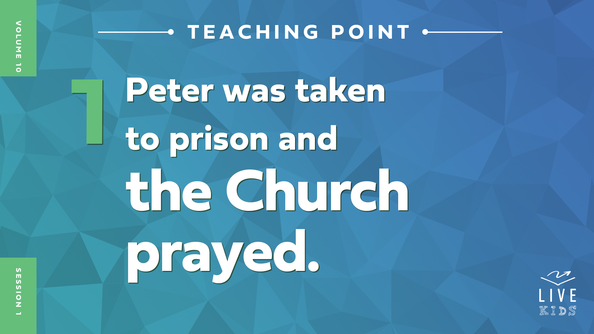

• *Read* [*Acts 12:1–5*](https://ref.ly/logosref/Bible.Ac12.1-5)*.*

Why is someone normally taken to prison or jail? *(Allow responses.)* Normally when someone is sent to prison, they have done something wrong. *(Hold up the handcuffs.)* They might have broken a law by stealing something or by hurting someone. What had Peter done that made him deserve being sent to prison? *(Allow responses.)*

He had done nothing against the law. He had done nothing wrong. He was simply a follower of Jesus. That sounds like a great thing to us, but King Herod was not a fan of Peter and the other believers.

King Herod arrested Peter and put him prison. A bunch of soldiers were in charge of watching over Peter. Herod didn’t want Peter to escape.

When other believers heard about Peter being arrested and placed in prison, they got together and prayed for him. Why did they pray? They knew that King Herod had recently killed James, one of the other disciples. They were probably worried that Peter would face the same thing unless God rescued him.

**2. God answered by sending help.**

• *Show the* ***Teaching Point 2 Slide.***

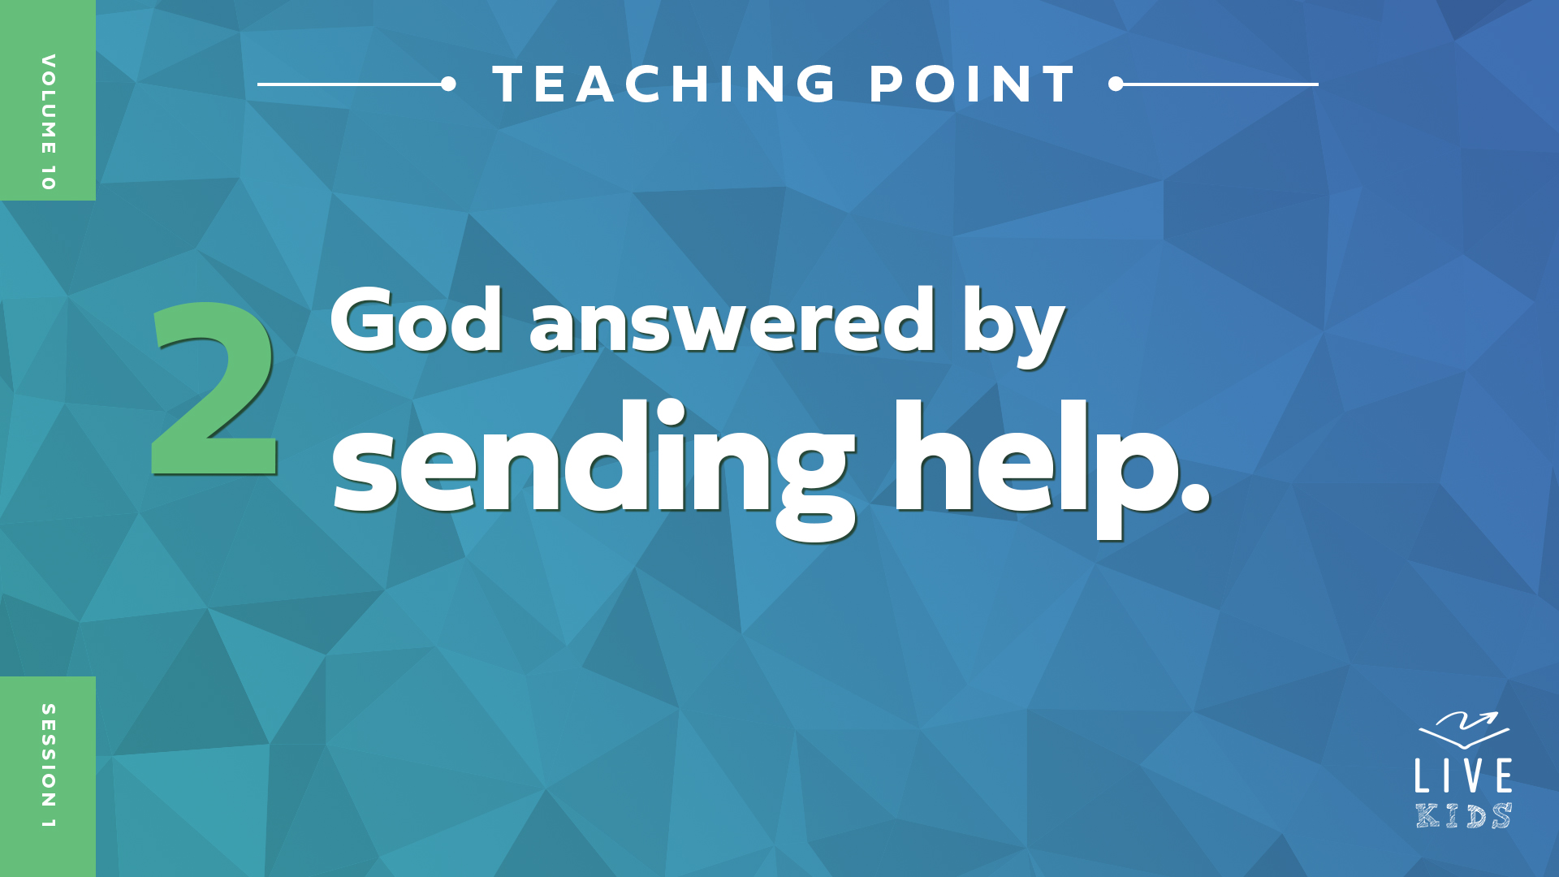

• *Read* [*Acts 12:6–11*](https://ref.ly/logosref/Bible.Ac12.6-11)*.*

The Church prayed for Peter to be rescued, and God heard their prayers. His response was miraculous to say the least. I need some volunteers to help me tell the next part of the story.

• *Choose a kid to play Peter. Put the handcuffs on him loosely, so they can be easily taken off. Give him a pillow and have him lay down and pretend to sleep.*

• *Choose two other kids to stand guard.*

Somehow, Peter managed to sleep while chained between soldiers. We can only imagine how shocking it must have been for him to wake up to a bright light.

• *Shine the flashlight on the Peter volunteer and have him wake up surprised.*

Even more shocking was that the light was an angel sent from God to rescue Peter from the prison.

• *Choose a volunteer to be the angel.*

The angel led Peter past all the guards, and a gate just opened for them. It’s not surprising that Peter wasn’t sure if it was really happening or not. He finally realized that he had really been rescued from the prison when he was out on the street and the angel left him. Would you have been surprised like Peter was? *(Group response)* I would have been surprised because things like that don’t normally happen.

• *Thank volunteers and have them be seated.*

Let’s find out what Peter did next!

**3. Peter’s friends were amazed that God answered their prayers.**

* *Show the* ***Teaching Point 3 Slide.***

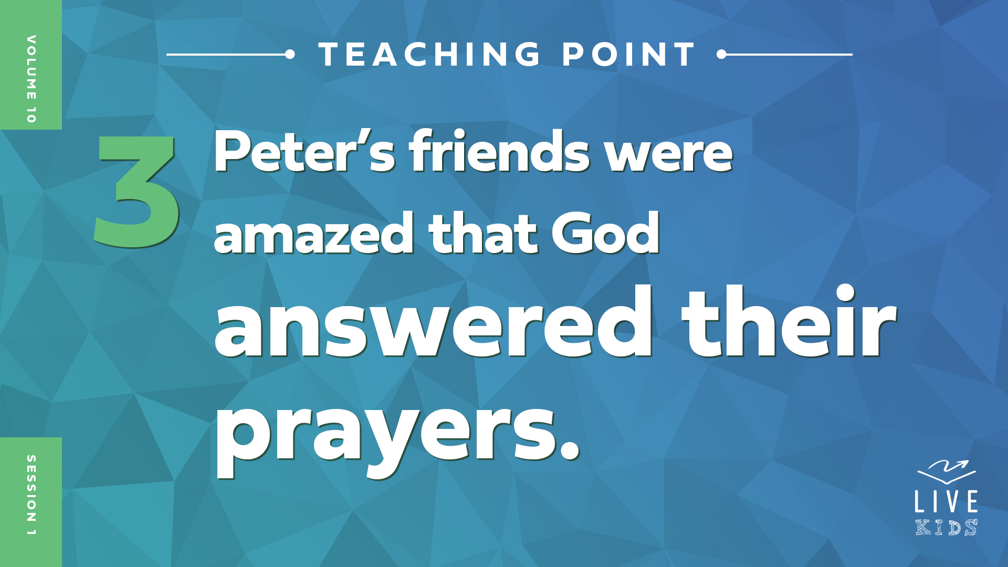

• *Read* [*Acts 12:12–16*](https://ref.ly/logosref/Bible.Ac12.12-16)*.*

Peter couldn’t wait to go to the house where the people had gathered to pray for him. Remember, back then there were no phones or computers. He couldn’t just call, text, or email them to say he had gotten out of prison. He had to show up!

Peter knocked on the door. Quick, everyone, loudly knock three times. *(Group response)* When he knocked, who came to the door? *(Group response)* A girl named Rhoda was so excited to tell the others Peter was there that she forgot to let him in! After she told the others, did they believe her? *(Group response)* No! None of them believed her. They thought it must have been an angel at the door. They didn’t believe that God answered their prayers that quickly.

Peter just kept on knocking. Let’s knock again three times. *(Group response)* They finally opened the door and were amazed to see Peter miraculously standing in front of them, a free man. Make a face to show how they probably looked when they saw Peter at the door. Ready? 1, 2, 3. *(Group response)* Those were some great expressions!

Even though the believers had been praying for Peter to be released, they were still shocked that the miracle had happened. It seems like Peter’s friends didn’t realize how powerful their prayers were. God’s Word shows us that they prayed and God answered by setting Peter free from an impossible situation. He may have been killed like James was if he hadn’t been rescued that night. Their urgent prayers were powerful!

**Prayer and Response**

*Consider playing a worship song softly in the background while kids pray.*

We can pray together like they did and believe for God to do something big in our life, too. **Our prayers are powerful.** If you have something you need us to pray for, big or small, you can ask for that right now. You don’t even have to tell us what it is if you don’t want to. God already knows that. Just stand up if you would like us to pray with you for a need.

• *Wait for the kids to respond.*

If you’re still sitting down, find someone near you who is standing and pray with them. Pray that God does a miracle for them like He did for Peter. Pray aloud for it together. God’s power can move when we pray!

• *Give kids time to pray with others before closing in prayer.*

**Prayer**

*Optional: Have the kids repeat phrases of the prayer after you.*

|  |
| --- |
| *Dear God, thank You for listening to my prayers and answering them. Help me to be bold about praying for others and about believing that You can help me when I need it. Amen.* |

**Faith Verse**

Our Faith Verse tells us that we should make every effort to be united with other believers. Prayer is one way we do that. Our verse is found in [Ephesians 4:3](https://ref.ly/logosref/Bible.Eph4.3). It says, “Make every effort to keep yourselves united in the Spirit, binding yourselves together with peace.” Let’s learn the actions together.

• *Play* ***Faith Verse Video****.*

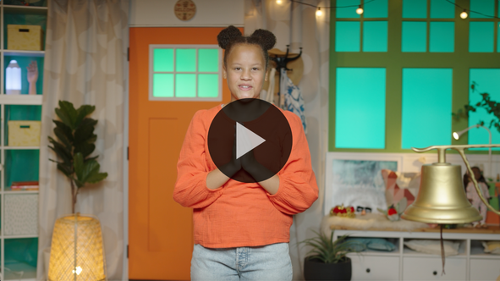

[Ephesians 4:3](https://ref.ly/logosref/Bible.Eph4.3) (NLT)

Make every effort to keep yourselves united in the Spirit, binding yourselves together with peace.

**Ephesians** *(hands at waist, spread apart, palms up and out)*

**4:** *(hands together like a clap)*

**3** *(hands opened to “book”)*

**Make every effort** *(sweep hands out and to the sides)*

**to keep yourselves united** *(bring hands together in a clap)*

**in the Spirit,** *(clap twice with the syllables of “Spirit”)*

**binding yourselves together** *(wrap arms around like a hug)*

**with peace.** *(bow head and whisper)*

**Faith Fact**

Before we go to our small groups, let’s review our Faith Fact again. **Our prayers are powerful.**

• *Show the* ***Faith Fact Slide****.*



Let’s say our Faith Fact together one more time and put some power behind your words! **Our prayers are powerful.** Remember to keep praying powerful prayers for others’ needs all week long.

• *Dismiss kids to Small Group time or to go home if your group time ends here.*

**Small Group**

**30 Minutes**

*This section can be done in conjunction with the large group or on its own if you do small groups with your kids. During Small Group time, the goal is to connect the kids with the Word of God and to each other. All activities are led by the small group leader.*

**Group Connection**

**Free Peter**

|  |
| --- |
| ***You Will Need***   * *Yarn, long enough to wrap around each kid in the group with space in between.*   *No prep is needed for this activity.* |

Peter’s friends knew they couldn’t free him from prison because there were guards in the way. Instead, they could pray together. When they did, Peter escaped without the guards seeing or feeling anything. Let’s play a game called Free Peter. I will choose one person to be Peter and one to be the angel. They’ll start in the middle of our group.

• *Choose these volunteers and have them sit in the middle.*

Everyone else will be the guards. You need to stand in a circle facing away from the middle. Now, touch the shoulder of the person next to you with your hands and spread the circle out.

• *Make sure there is room between the kids for someone to crawl between them without touching them.*

Next, we need to add a barrier so that Peter and the angel can’t escape easily.

• *Take the yarn and go around the outside of the group at their waists. Tie the yarn and have the kids step further out to stretch the yarn tight.*

Okay, we’re ready. The guards around the outside will close their eyes because they didn’t expect Peter to escape that night. The angel will lead Peter out of prison by going under the yarn. The goal is for them to escape secretly. If you feel any movement because they touch you or the yarn, raise your hand right away. Let’s play.

• *Play the game and give everyone a chance to be Peter or the angel.*

• *Optional: Make each round more challenging by lowering the yarn closer to the ground.*

Great job, everyone! Peter’s friends knew that prayer was their best option, so they prayed together. Only God could deliver Peter from prison, and God came through for them in a big way. He can answer our prayers in powerful ways, too!

**Bible Lesson Recap**

• *If small group activities are not immediately following large group time, you may want to read the Bible story passage before the discussion.*

|  |
| --- |
| ***You Will Need***   * *Bibles for kids in the group to share*   *No prep needed for this activity.* |

**Bible Story Review: The Church Prays and Peter Is Set Free** [**Acts 12:1–16**](https://ref.ly/logosref/Bible.Ac12.1-16)

What was your favorite part of the Bible story about Peter? *(Allow responses.)* The Early Church risked everything to spread the good news of Jesus. They were persecuted, beaten, put in prison, and even killed because they loved Jesus and told others about Him.

King Herod was one of the many leaders who did not like what Jesus’ followers were doing. When Peter was put in prison, his friends began to pray for his release. They didn’t realize the miracle God had in store for Peter because God was the power behind their prayers. They just knew that they had to pray together.

God heard their prayers and sent an angel to help Peter escape from prison. It was like something out of a dream, but it really happened. The angel was able to get Peter past the soldiers and through the iron gates. When Peter realized that he was really awake and out of the prison, he went to where the believers were praying. He couldn’t wait to show them that their prayers had been answered. When they saw that Peter was really at the door, they were amazed at what God had done.

• *Give each kid a Bible and read the Bible story together.*

**Group Discussion**

*Feel free to use all or just a few questions as a jumping-off place for good discussion. Questions marked with * are designed for more conversation. Adjust the questions based on the age or maturity of your group. Typically, older kids will be able to dive a little deeper than younger ones.*

**Questions**

Why was Peter thrown into prison?

How do you think Peter felt when he was thrown into prison?

Why do you think King Herod placed so many soldiers around Peter?

How do you think Peter responded to the angel who appeared in the prison?

* Do you think seeing Peter being freed from the prison changed the way the people prayed after that? Why or why not?

What would your reaction have been if Peter had showed up at your house when he was supposed to be in prison?

What does this Bible story teach us about praying together?

* Do you believe your prayers can be powerful like this? Why or why not?

**Live It**

**Faith Fact**

Our Faith Fact today is **Our prayers are powerful**. We can receive the Holy Spirit’s powerful help with our prayers like the Early Church did. We have the same Holy Spirit living inside us and working through us. It’s through His power that we can pray for miracles. We don’t have to pray alone! We can ask other believers to pray with us for our needs.

**Challenge**

What do you need prayer for? Find a prayer partner this week to share your needs with and pray together for each other’s needs. Your prayer partner can be a parent, a sibling, or a friend who is a Christian. Take the time to meet and pray with them at least once this week. Remember, there is power behind praying together.

**Prayer**

*Finish group discussion by sharing prayer requests and praise reports. Keep track of your small group’s prayer requests and review them each time you meet.*

• *Have kids share and pray for each other’s prayer requests.*

|  |
| --- |
| *Dear God, help us to take the time to pray together with other believers this week. We are asking You to put Your power behind our prayers. We believe You will answer them. Amen.* |

**Faith Verse Review**

|  |
| --- |
| ***You Will Need***   * *Balloons, two or three per group*   *No prep is needed for this activity.* |

It’s time to practice our new Faith Verse from [Ephesians 4:3](https://ref.ly/logosref/Bible.Eph4.3). It teaches us that God wants us to work together with other believers and support each other. Let’s do the actions as we learn it.

• *Show* ***Faith Verse Video****.*



[Ephesians 4:3](https://ref.ly/logosref/Bible.Eph4.3) (NLT)

Make every effort to keep yourselves united in the Spirit, binding yourselves together with peace.

Let’s say it together again before we do a fun Faith Verse activity together.

• *Say the verse as a group a couple of times.*

**Faith Verse Fun**

**Powerful Pop!**

*(Hold up a balloon.)* Do you think I can blow up this balloon and get it to pop? *(Group response)* How many times do you think you can say the Faith Verse together before I pop this balloon? *(Allow responses.)* Let’s find out who guessed right. You count how many times you say the Faith Verse together while I blow up the balloon.

• *Blow up the balloon as kids say the verse repeatedly until the balloon pops.*

• *Play again if you have time.*

You were faster than I thought! Maybe I’m slower at blowing up a balloon than I realized. Either way, great job learning our new Faith Verse!

**Activity Page**

**Prayer Power**

|  |
| --- |
| ***You Will Need***   * ***Small Group Activity Page****, one per kid* * *Pencils or pens, one per kid*   ***Getting Ready***   * *Print copies of the* ***Small Group Activity Page****, one per kid.* |

Our Bible story is a great reminder of how powerful our prayers can be. When we pray together, it can help us trust God even more. Peter’s friends were shocked at how quickly and miraculously God answered their prayers.

• *Hand out a copy of the* ***Small Group Activity Page*** *and a pencil to each kid.*

For this Activity Page, follow the directions to answer the question. Then, we’ll finish the page together.

• *After kids have completed the page, talk about what miracles you can pray for together.*

Peter’s release from prison is a great reminder that we can pray together for big things. Our Faith Fact is so true. Say it with me. **Our prayers our powerful.**

**Dismissal**

There is nothing more powerful than a group of believers coming together to pray. We are better together. Let’s pray together one more time before we go.

**Prayer**

|  |
| --- |
| *Dear God, thanks for giving us the opportunity to talk to You together. Help us to use the power of prayer every day this week. Remind us to pray for each other’s needs. Amen.* |

**Faith Fact Recap**

• *Show the* ***Faith Fact Slide****.*



Let’s say our Faith Fact together one more time before we go. **Our prayers are powerful**. We can ask people to pray with us. We can pray and talk to God about anything and everything going on in our life. He cares about all the little and big things and wants to be a part of it all.

• *Send home the* ***Small Group******Activity Page.***

• *Remind parents that there are* ***Family Devotions*** *available on the app to do with their kid.*

• *Tell everyone the date and time for the next session.*